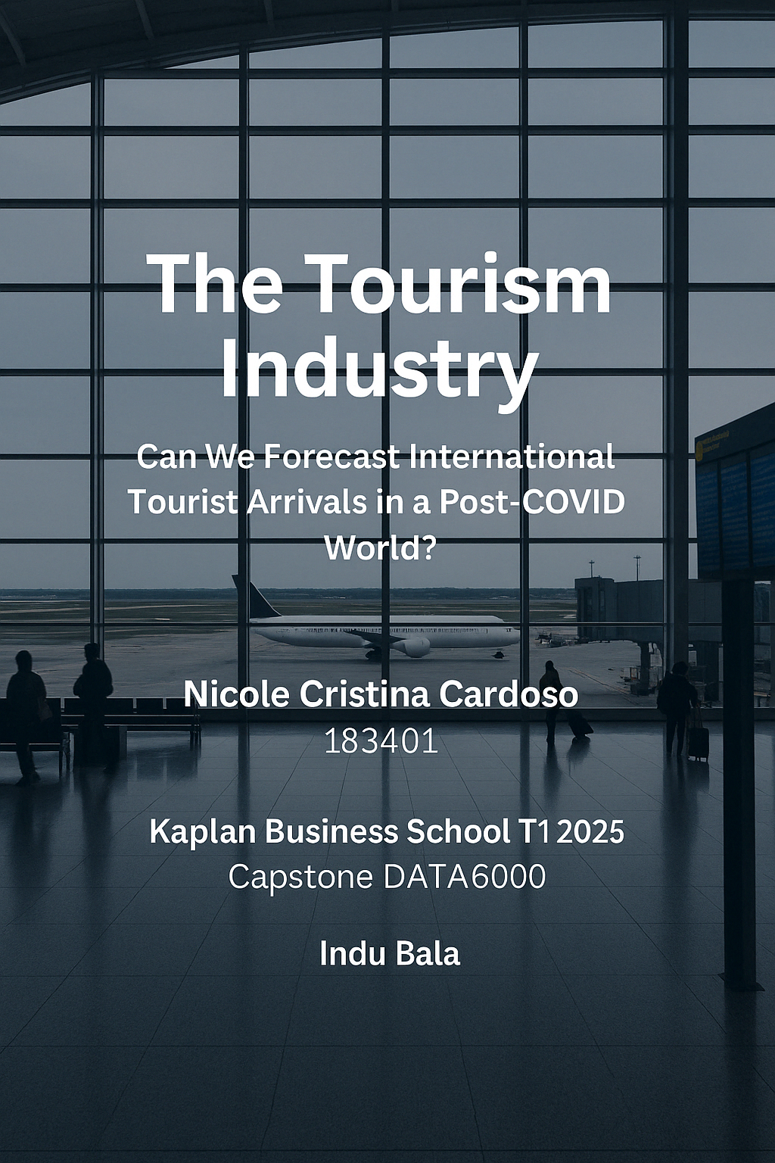

**Table of Contents**

1. Executive Summary .............................................................................................3
2. Tourism Industry…….............................................................................................3
3. Key Business Problems ........................................................................................5
4. Existing Analysis and Methodologies ....................................................................6
5. Data Sources .......................................................................................................7
6. Selected Business Problem ................................................................................10
7. Proposed Forecasting Approach ........................................................................ 11
8. References ........................................................................................................12

**Executive Summary**

This project studies the challenges that Australia's tourist sector has encountered since COVID-19. The challenges mapped addressed in this project are:

* Predicting demand for accommodation
* Changing marketing tactics to fit the changing traveler characteristics following the COVID-19 pandemic
* Forecasting monthly foreign arrivals by purpose in Australia

To address these challenges a forecasting method utilizing ARIMA and Prophet models backed by ABS datasets will be considered. Delivering segmented, data-driven insights that support the tourism industry's confident planning and efficient resource allocation is the aim.

**The Tourism Industry**

The tourism industry is one of the most important, dynamic and economically sectors in Australia. Before the COVID-19 pandemic, $60 billion were contributed annually by tourism to the country’s economy and provided more than 660 thousand jobs (Tourism Australia, 2024). Overseas tourists- especially from China, the United States, New Zealand, and the United Kingdom—played a key role in sustaining this system

However, the pandemic severely affected global mobility and tourism. The impact has been described as both rapid and transformative (Gössling, Scott & Hall, 2021). Borders were closed, flights were cancelled, and strict quarantine measures were applied, resulting in a 99% fall in international arrivals to Australia between March 2020 and March 2021 (Australian Bureau of Statistics, 2021). Since 2022, the country has seen a gradual recovery, influenced by ongoing health concerns, economic uncertainty, and geopolitical events.

On the graph below, it’s possible to follow the decline during Covid and then the slow recovery the country’s been having since then.

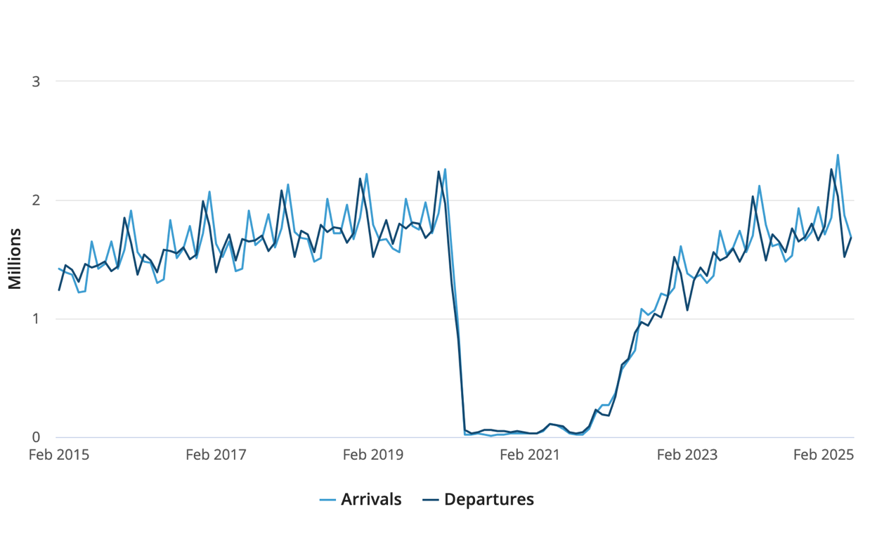

Figure 1.0: Departures and Arrivals per Years in Australia (source: Australian Bureau of Statistics, 2024)

Key Market Insights

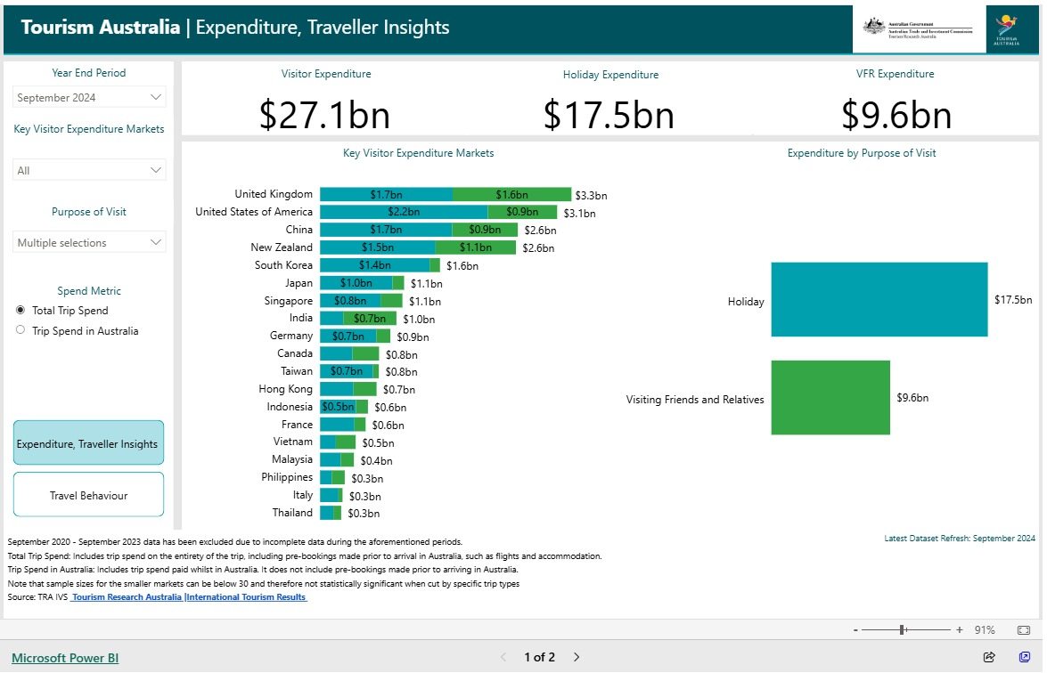

Figure 2.0: Expenditure, Traveler Insights (source: Australian Bureau of Statistics, 2024)

According to recent Tourism Australia data displayed above, tourist expenditure reached $27.1 billion in the year ending in September 2024, with $17.5 billion spent on vacations and $9.6 billion spent on visits to friends and relatives (Australian Bureau of Statistics, 2024). This suggests that traveling for holidays remains the main source of international tourism revenue, almost two-thirds of total visitor spending comes from this type of travels.

After this analysis, it’s possible to understand the tourism industry is today confronted with three significant business issues:

* *Planning for Accommodation Demand in Different Regions*:  
  It is difficult for travel agencies to balance supply and demand, particularly in seasonal or regional locations. Hotel capacity planning and infrastructure investment optimization may be aided using predictive analytics and small area lodging data.
* Adapting Marketing Techniques to New Traveler Profiles:  
  Understanding traveler preferences is essential in this shift, particularly in identifying demand for smarter, tech-enhanced tourism experiences (Wang et al., 2016).
* *Predicting Foreign Arrivals After COVID:* For the tourism industry to allocate resources effectively, a precise forecasting of foreign arrivals is essential. Without it, business could lost revenue, have inefficient supply chains, and unsatisfactory customer experiences.

A good strategy that can be put in place is the segmented forecasting dashboard that projects monthly foreign arrivals by nation and travel purpose. Tourism stakeholders can improve staffing, marketing, and infrastructure planning by integrating interactive visual tools (like Power BI) with time series models like ARIMA or Prophet. Because it adapts insights to post-COVID visitor behavior and provides real-time, data-driven decision support, this integrated approach is unique.

**Existing Analysis and Methodologies**

For many years, many organizations have relied on forecasting in the tourist sector. However, the COVID-19 pandemic's effects revealed how ineffective the conventional forecasting methods were and led to important research for more flexible and reliable predicting techniques.

Forecasting demand for tourism has long been a focus of the profession, with important reviews showing how models have changed over time (Song & Li, 2008). To forecast visitor arrivals in Australia, Zhang and Lin (2021) used the SARIMA (Seasonal Auto-Regressive Integrated Moving Average) model. Although their model performed well in stable environments, it had trouble adapting to unpredicted changes, like epidemic (Zhang et al., 2021).

To improve the accuracy of short-term tourism demand forecasting, Luo et al. (2024) suggested a hybrid model, considering ARIMA with Prophet. Their findings showed that integrating statistical and machine learning approaches significantly increased forecast robustness in the face of unanticipated events(Luo et al., 2024).

Kourentzes et al. (2022) have investigated a range of time series models, such as ARIMA, exponential smoothing, and hybrid techniques, for post-pandemic tourist forecasting. Their research emphasized the difficulties caused by unpredictability and volatility in patterns of overseas immigration, concluding that no single model is acceptable for every case. (Kourentzes et al., 2022).

To increase prediction accuracy, some studies have combined forecasting models with external factors including foreign exchange rates, consumer confidence indices, and mobility constraints brought on by COVID. Deep learning hybrids like recurrent neural networks are also being explored for improved multivariate forecasting accuracy (Kourentzes & Athanasopoulos, 2019).

Most current research either uses generic forecasting without breaking down by nation of origin or visitation goal or concentrates on pre-COVID information. This leaves a void for more precise, current, and useful forecasting that is adapted to the post-COVID world.

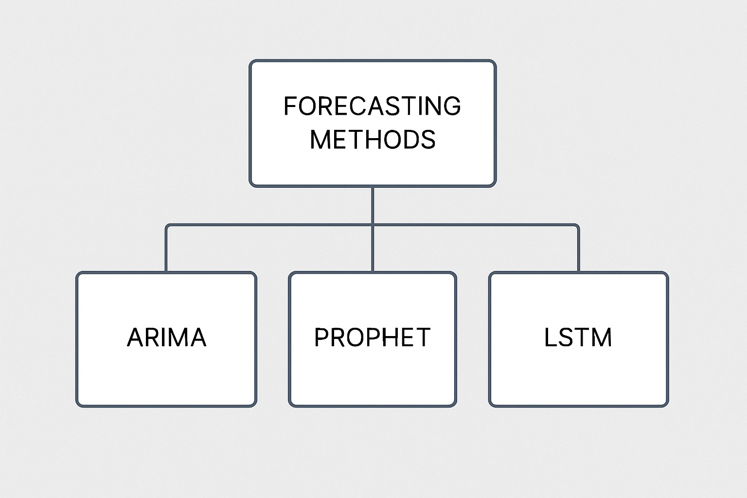

Figure 3.0: Forecasting methods used on the analysis and methodologies mentioned

**Data Sources**

The proposed data sources include:

* <https://www.abs.gov.au/statistics/industry/tourism-and-transport/overseas-arrivals-and-departures-australia/jan-2025>
* <https://www.abs.gov.au/statistics/industry/tourism-and-transport/overseas-travel-statistics-provisional/jun-2021>
* <https://www.abs.gov.au/statistics/industry/tourism-and-transport/tourist-accommodation-small-area-data-australia/jun-2013>

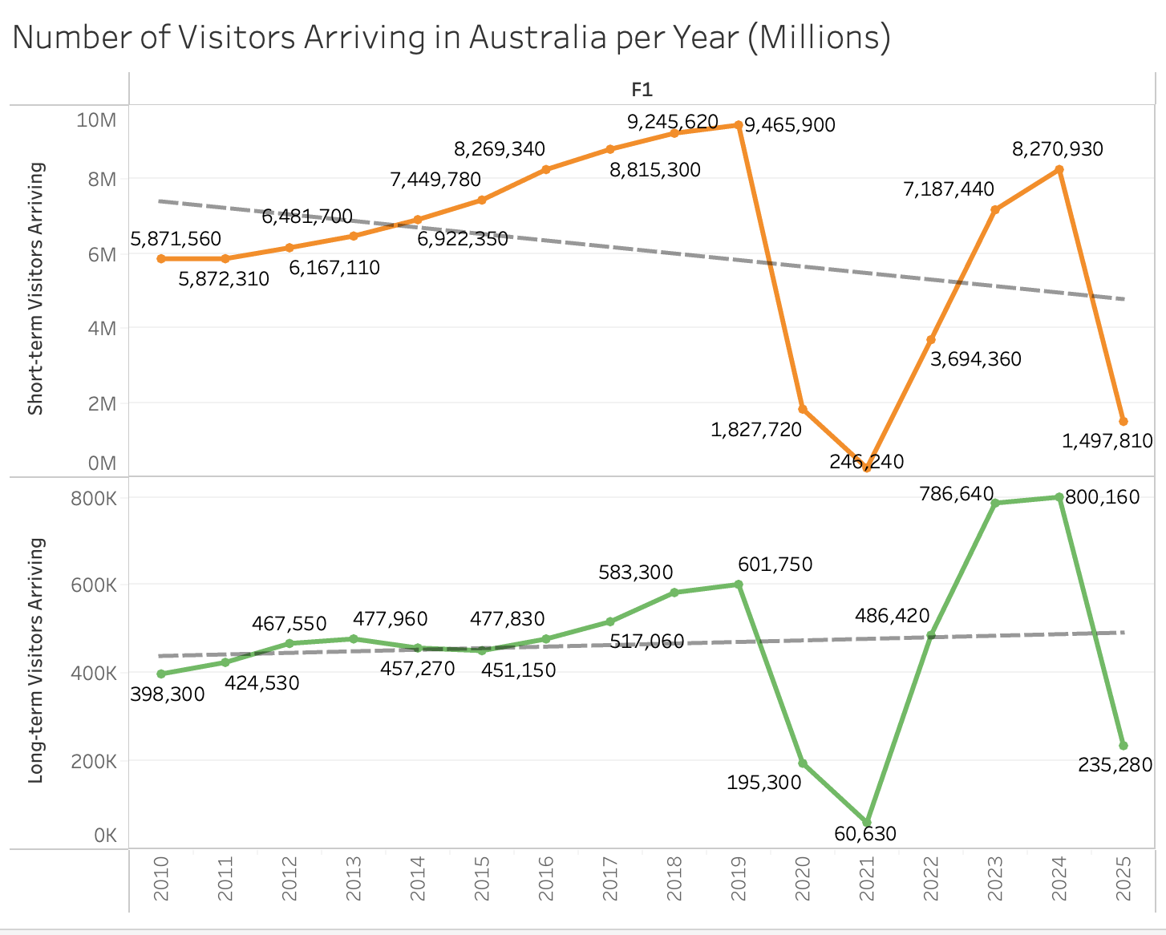

Figure 4.0 and 5.0: Number of Visitors Arriving in Australia per Year (Millions). Being short-term visitors that stayed less than a year and long-term a year or more

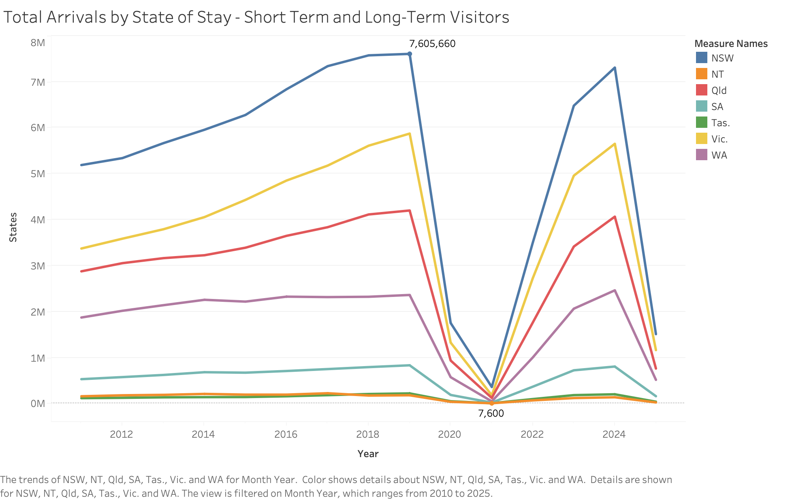

Figure 6.0: Total Arrivals by State of Stay - Short Term and Long-Term Visitors

In line with the suggested forecasting goal, the chosen datasets offer a solid basis for both descriptive and predictive analytics. To segment the forecasts, the Overseas Arrivals and Departures dataset enables comprehensive trend analysis by country of origin and purpose of visit.

To help the model consider the behavior changes brought by Covid-19, the travel records from mid-2021 provide important insight into the early phases of recovery. Despite being older, the hotel data can help with infrastructure planning and regional comparisons by linking travel patterns with the demand for local accomodations.

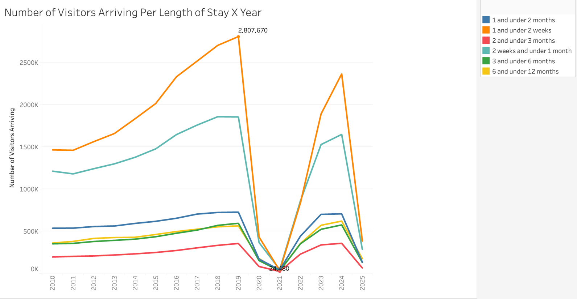

Figure 7.0: Number of Visitors Arriving Per Length of Stay X Year

**Selecting a Business Problem**

*How can we accurately forecast monthly international tourist arrivals to Australia by country of origin and purpose of visit?*

Time series models, including ARIMA and Facebook Prophet, will be the main emphasis of the forecasting methodology because of their ability to manage trends, seasonality, and holiday effects. Depending on how the data behaves, a hybrid method might also be considered.

Because most of the previous research either concentrates on pre-pandemic data or does not segment by visitor characteristics such place of origin or travel intent, this analysis is unique. The goal of this study is to produce more detailed and useful forecasts by taking these elements into account.

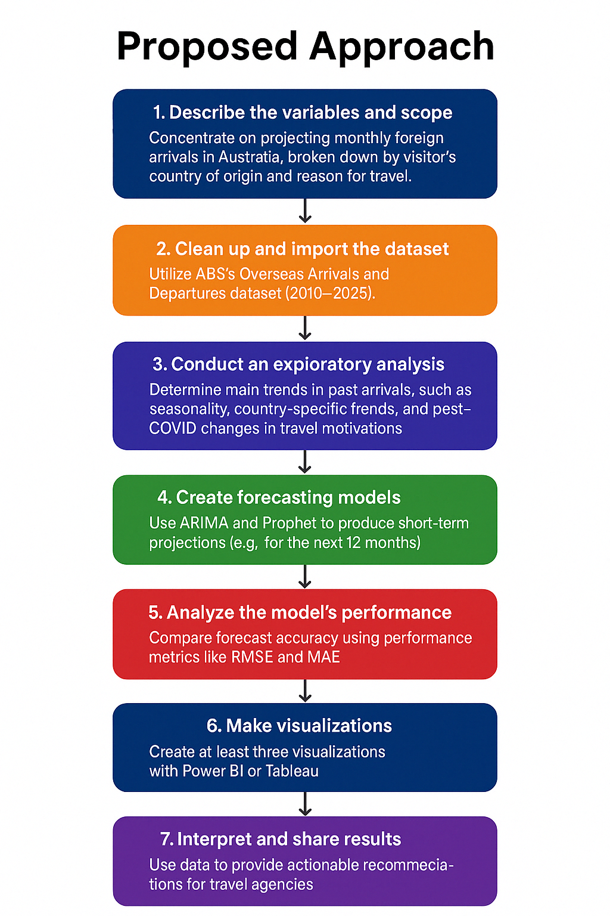

Figure 8.0: Proposed Approach Flowchart

**References**

Tourism Australia (2024) Insights - Corporate - Tourism Australia. [online] Available at: <https://www.tourism.australia.com/en/insights.html> [Accessed 12 Apr. 2025].

Australian Bureau of Statistics (2024) Overseas Arrivals and Departures, Australia, July 2020. [online] Available at: <https://www.abs.gov.au/statistics/industry/tourism-and-transport/overseas-arrivals-and-departures-australia/latest-release> [Accessed 12 Apr. 2025].

Zhang, Y., Li, G., Muskat, B., Vu, H.Q. and Law, R. (2021) ‘Predictivity of tourism demand data’, Annals of Tourism Research, 89, p.103234. doi: <https://doi.org/10.1016/j.annals.2021.103234>

Herrera, G.P., Constantino, M., Su, J.-J. and Naranpanawa, A. (2022) ‘Forecasting inbound tourism in light of data structure: A case study of Australia using deep learning’, Tourism Analysis. doi: <https://doi.org/10.3727/108354222x16578978994073>

Luo, Q., Cai, S., Lv, N. and Fu, X. (2024) ‘Daily forecasting of tourism demand: An ST-LSTM model with social network service co-occurrence similarity’, Information & Management, 62(1), p.104056. doi: <https://doi.org/10.1016/j.im.2024.104056>

Song, H. and Li, G. (2008) ‘Tourism demand modelling and forecasting—A review of recent research’, Tourism Management, 29(2), pp.203–220. doi: <https://doi.org/10.1016/j.tourman.2007.07.016>

Wang, X., Li, X., Zhen, F. and Zhang, J. (2016) ‘How smart is your tourist attraction? Measuring tourist preferences of smart tourism attractions via a FCEM-AHP and IPA approach’, Tourism Management, 54, pp.309–320. doi: <https://doi.org/10.1016/j.tourman.2015.12.003>

Wen, J., Kozak, M., Yang, S. and Liu, F. (2020) ‘COVID-19: Potential effects on Chinese citizens’ lifestyle and travel’, Tourism Review. doi: <https://doi.org/10.1108/TR-03-2020-0110>

Gössling, S., Scott, D. and Hall, C.M. (2021) ‘Pandemics, tourism and global change: a rapid assessment of COVID-19’, Journal of Sustainable Tourism, 29(1), pp.1–20. doi: <https://doi.org/10.1080/09669582.2020.1758708>

Kourentzes, N. and Athanasopoulos, G. (2019) ‘Cross-temporal recurrent neural networks: A deep learning approach to multivariate forecasting’, International Journal of Forecasting, 35(3), pp.763–775. doi: <https://doi.org/10.1016/j.ijforecast.2018.09.003>

‌